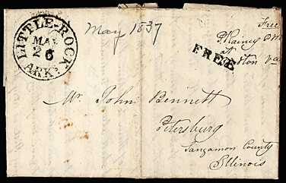

Auction House | Sale # | Date | Lot # | Originating | Date | Destination
 |  |  |  | Post Office | Sent | Post Office
Nutmeg | 93 | 12/16/04 | 25 | Little Rock | 5/26/1837 | Petersburg, IL

LITTLE-ROCK, ARKs, MAY/26 1837 CDS on FL w/ h/s "FREE", signed by P.Rainey, PM at Boydton VA, addr Petersburg IL, VF

Price Estimate: $80.00

