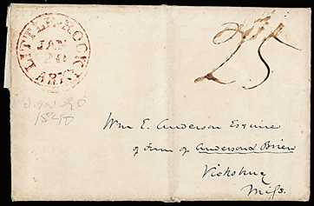

Auction House | Sale # | Date | Lot # | Originating | Date | Destination
 |  |  |  | Post Office | Sent | Post Office
Nutmeg | 93 | 12/16/04 | 26 | Little Rock | 1/20/1840 | Philadelphia, PA

LITTLE-ROCK, ARKs, JAN/20 1840 Red CDS on FL w/ ms "25" rate, addr Philadelphia PA, VF

Price Estimate: $40.00

