Civil War Cover, HQ E. Arkansas Dist to DC, #65

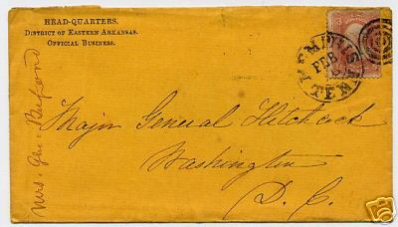

Ebay Item 5572507701

This cover has a corner card inscription of "Head-quarters, District of Eastern Arkansas, Official Business." On the left side is written "Mrs. Gen. Buford." It is franked with #65, and is addressed to Major General Hitchcock, Washington D.C. Postmark of Memphis, Tenn, possibly Feb 18. On the reverse is written in pencil, presumably by the previous owner, "scarce corner card," and "General Hitchcock Commisioner (sic) for the Exchange of Prisoners." Cover is in nice condition, with a small tear at top center, and the stamp has a straight right edge, probably cut down. Opening bid of $40.00.

